**BCS 2107 Database Systems 1**

**Semester Project**

Create and build a database using Structured Query Language on MS Access platform to input, store and retrieve data for the scenario below.

***This database is expected to serve a diversified company that has more than 6 businesses within East Africa region such as FMCG wholesale & distribution; travel; agricultural farm input and equipment with total revenue in millions of shillings.***

***This company has the challenge of operating multiple businesses that are completely different in nature and totally independent in terms of IT infrastructure, the company has operational data locked within each business. The absence of data integration among the businesses hindered the company from implementing such initiatives as 360-degree customer view and a conglomerate-wide loyalty program.***

**Requirements**

1. Provide the following items in a report:
2. Database Design document that will include:
   1. Objectives of database
   2. Kind of database
   3. Characteristics of Database e.g data manipulation language, source of data (data entry or import/external data)
   4. Logical data model through Entity Relationship diagram
3. Normalisation process for the database created
   1. Database design schema e.g network, relational or star

This assignment will be done in groups as assigned in elearning portal:

**Delivery/Submission timelines**

Database Systems Report (highlighted above) – 27 October 2023

Presentation and Demonstration – 22 November 2023

**Objectives of database**

This database's main goal is to streamline data integration and enhance the efficient management of diverse businesses in a conglomerate that operates across East Africa. The company encounters issues because its different businesses have separate IT infrastructures, hindering efforts to achieve a comprehensive customer perspective and implement a loyalty program that spans the entire conglomerate. The database is designed to tackle these hurdles and provide a solution for centralized data management.

**Kind of database**  
Is a well-organized filing system for digital information. It's designed to store data in a structured way. Data is organized into tables, where each table represents a specific category of information. These tables are connected through relationships, much like how different pieces of information are linked in real life. The relational database uses a language called SQL (Structured Query Language) to manage and query the data. SQL allows you to perform various operations on the data, such as retrieving, updating, or deleting records. It ensures data integrity and consistency by enforcing rules that govern how data is stored and related.  
  
  
FCMG WHOLESALE AND DISTRIBUTION SECTION ERD  
  
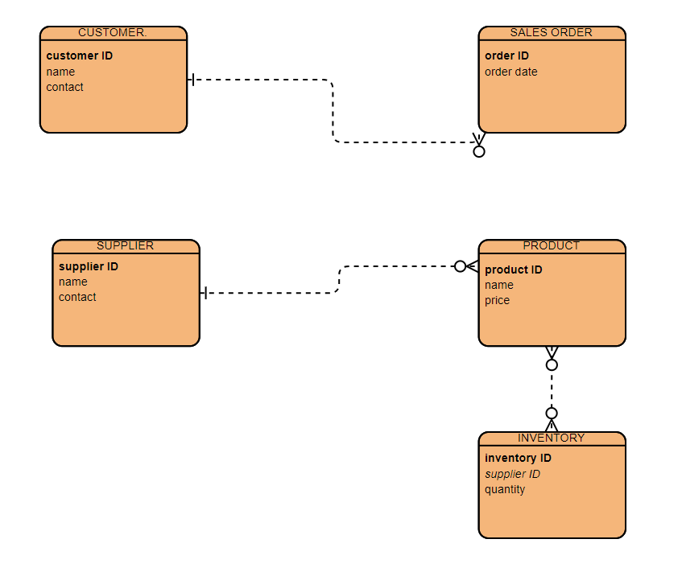

TRAVEL SECTION ERD  
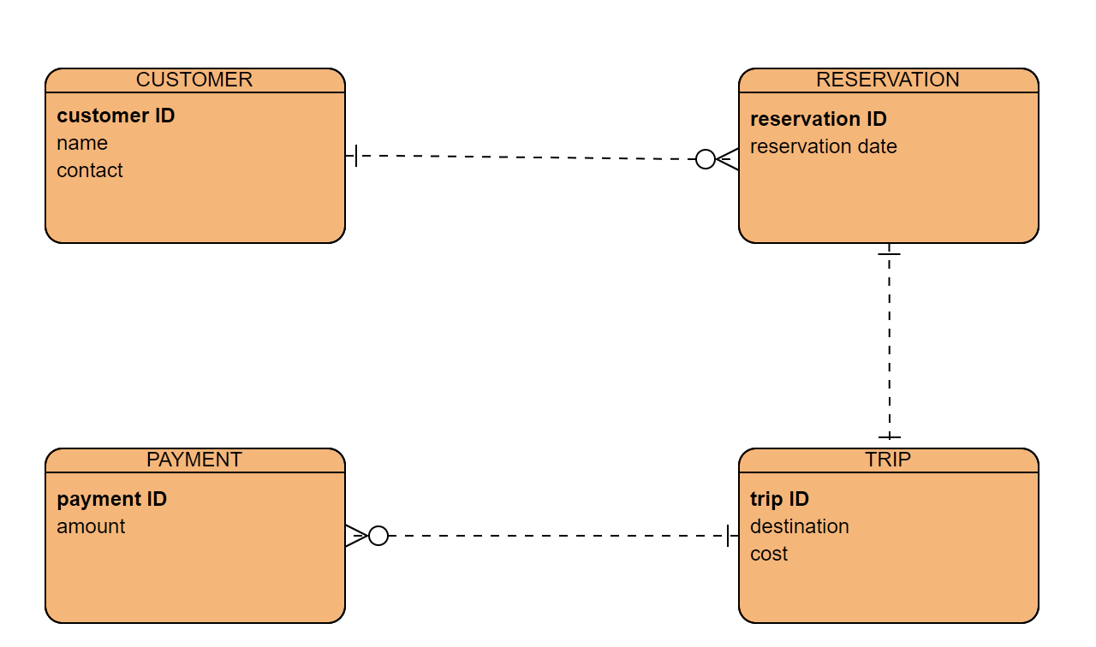

AGRICULTURAL FARM INPUT AND EQUIPMENT ERD.  
  
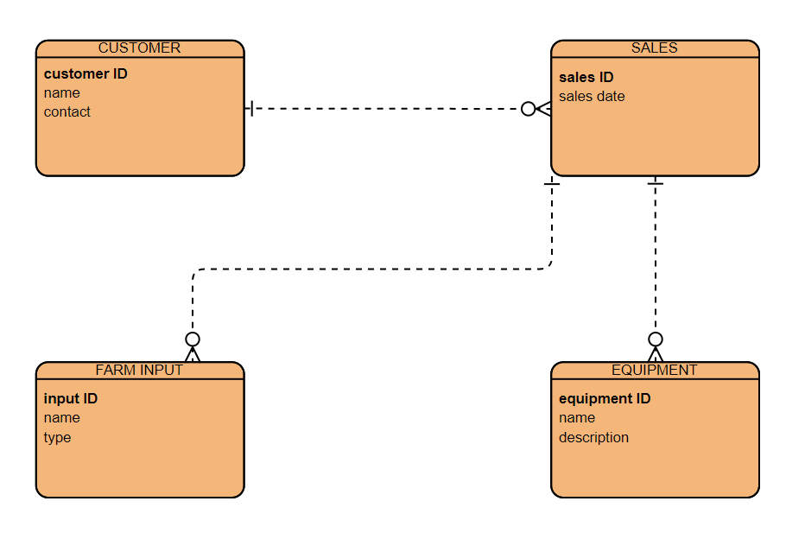

CONGLOMERATE ERD.  
  
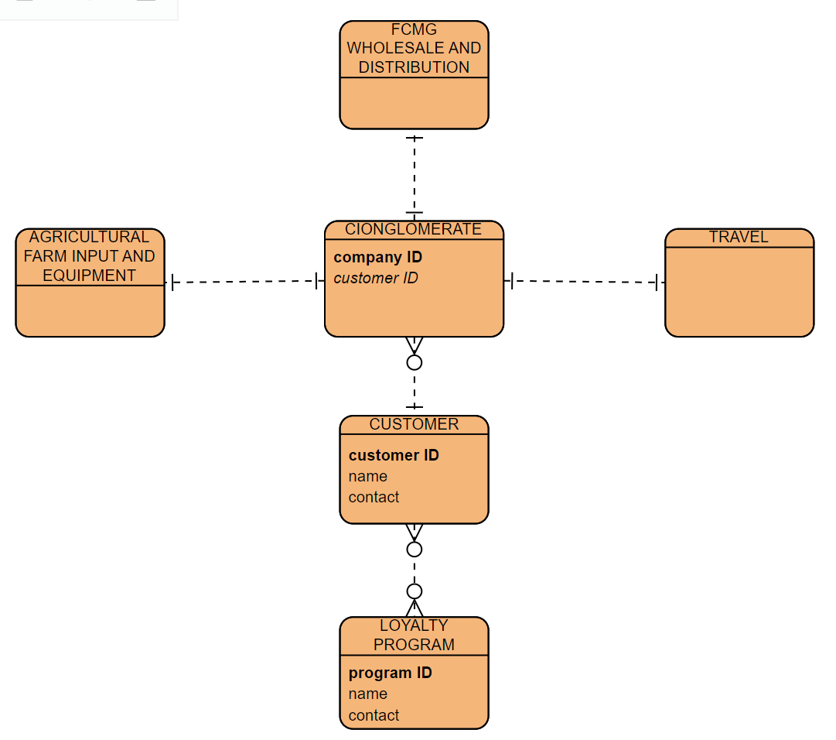

Relationships:

There is a One-to-One relationship between Conglomerate and fcmg wholesale and distribution.

There is a One-to-One relationship between Conglomerate and travel.

There is a One-to-One relationship between Conglomerate and agricultural farm input and equipment.

There is a One-to-Many relationship between Customer and Conglomerate since one customer can be a client for more than one company owned by the conglomerate.

There is a Many-to-Many relationship between Loyalty Program and Customer (assuming multiple customers can participate in the same program, and a customer can join multiple programs).

**NORMALISATION.**

The data from the ERD is already in 1NF form as each table has a primary key and all attributes have atomic values. In 2NF, we deal with partial dependencies by breaking down tables that have composite primary.

**2NF**

CUSTOMER

|  |  |  |
| --- | --- | --- |
| CUSTOMER ID | NAME | CONTACT |

SALES ORDER

|  |  |  |
| --- | --- | --- |
| ORDER ID | DATE | CUSTOMER ID (FK) |

SUPPLIER

|  |  |  |
| --- | --- | --- |
| SUPPLIER ID (PK) | NAME | CONTACT |

PRODUCT

|  |  |  |
| --- | --- | --- |
| PRODUCT ID (PK) | NAME | PRICE |

INVENTORY

|  |  |  |
| --- | --- | --- |
| INVENTORY ID (PK) | SUPPLIER ID (PK) | QUANTITY |

RESERVATION

|  |  |  |
| --- | --- | --- |
| RESERVATION ID (PK) | RESERVATION DATE | CUSTOMER ID (FK) |

TRIP

|  |  |  |
| --- | --- | --- |
| TRIP ID (PK) | DESTINATION | COST |

PAYMENT

|  |  |  |
| --- | --- | --- |
| PAYMENT ID (PK) | AMOUNT | TRIP ID (FK) |

EQUIPMENT

|  |  |  |
| --- | --- | --- |
| EQUIPMENT ID (PK) | NAME | DESCRIPTION |

FARM INPUT

|  |  |  |
| --- | --- | --- |
| INPUT ID (PK) | NAME | TYPE |

COMPANY

|  |  |  |
| --- | --- | --- |
| COMPANY ID (PK) | CUSTOMER ID (FK) | SUPPLIER ID (PK) |

In 3NF, we address transitive dependencies by separating out related data into their own tables.

**3NF**

CUSTOMER

|  |  |  |
| --- | --- | --- |
| CUSTOMER ID (PK) | NAME | CONTACT |

SALES ORDER

|  |  |  |
| --- | --- | --- |
| ORDER ID (PK) | DATE | CUSTOMER ID (FK) |

SUPPLIER

|  |  |  |
| --- | --- | --- |
| SUPPLIER ID (PK) | NAME | CONTACT |

PRODUCT

|  |  |  |
| --- | --- | --- |
| PRODUCT ID (PK) | NAME | PRICE |

INVENTORY

|  |  |  |
| --- | --- | --- |
| INVENTORY ID (PK) | SUPPLIER ID (FK) | QUANTITY |

RESERVATION

|  |  |  |
| --- | --- | --- |
| RESERVATION ID (PK) | RESERVATION DATE | CUSTOMER ID (FK) |

TRIP

|  |  |  |
| --- | --- | --- |
| TRIP ID (PK) | DESTINATION | COST |

PAYMENT

|  |  |  |
| --- | --- | --- |
| PAYMENT ID (PK) | AMOUNT | TRIP ID (FK) |

EQUIPMENT

|  |  |  |
| --- | --- | --- |
| EQUIPMENT ID (PK) | NAME | DESCRIPTION |

FARM INPUT

|  |  |  |
| --- | --- | --- |
| INPUT ID (PK) | NAME | TYPE |

COMPANY

|  |  |  |
| --- | --- | --- |
| COMPANY ID (PK) | CUSTOMER ID (FK) | SUPPLIER ID (FK) |

LOYALTY PROGRAM

|  |  |  |
| --- | --- | --- |
| PROGRAM ID (PK) | PROGRAM NAME | PROGRAM DESCRIPTION |

CUSTOMER_LOYALTYPROGRAM(MANY-TO-MANY RELATIONSHIP TABLE)

|  |  |
| --- | --- |
| CUSTOMER ID (FK) | PROGRAM ID (FK) |

**DATABASE SCHEMA**

